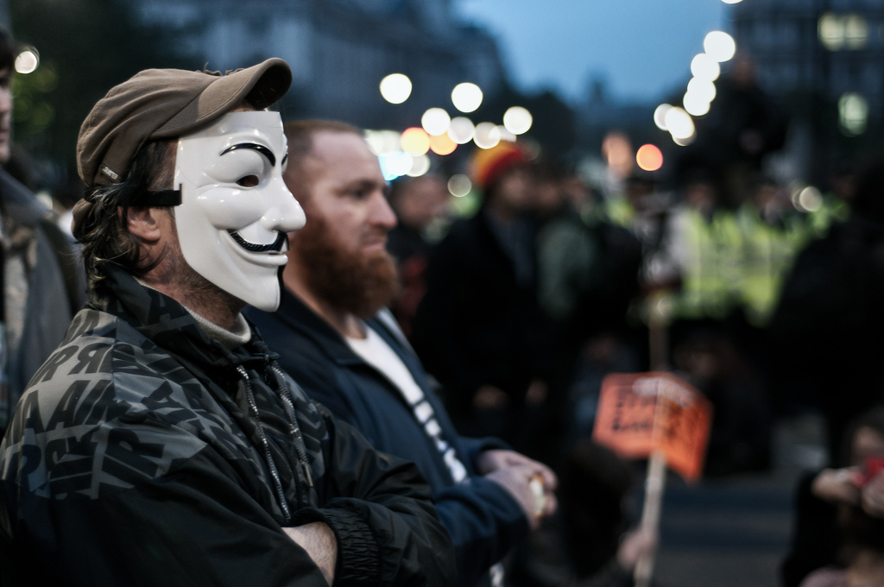

Upon first glance this photo has a very interesting, but somewhat creepy subject matter. It isn't immediately apparent as to what is going on, and makes it a really interesting piece to look at. In the foreground there is a man wearing a mask but for what reason? As your eyes wander into the out of focus background you can make out what appears to be an orange sign on a stick and some people, possibly law enforcement, wearing yellow reflective vests. Upon first thought one may come to the conclusion that this man is at a riot or a protest (could be the same depending on energy levels), but in a situation like that law enforcement never wears bright reflective clothing. It could possibly me a march for a cause or a parade, but once again the character in the mask gives some doubt. The contrast and similarity in density throughout really makes the oddities in the background stand out, but not too much as the flare off of the lights helps blend the details together perfectly.